**Solution Architecture:**

|  |  |
| --- | --- |
| Team ID | PNT2022TMID20252 |
| Project Name | IoT based smart crop protection system for agriculture |
| Maximum Marks | 4 Marks |

**SOLUTION ARCHITECTURE**

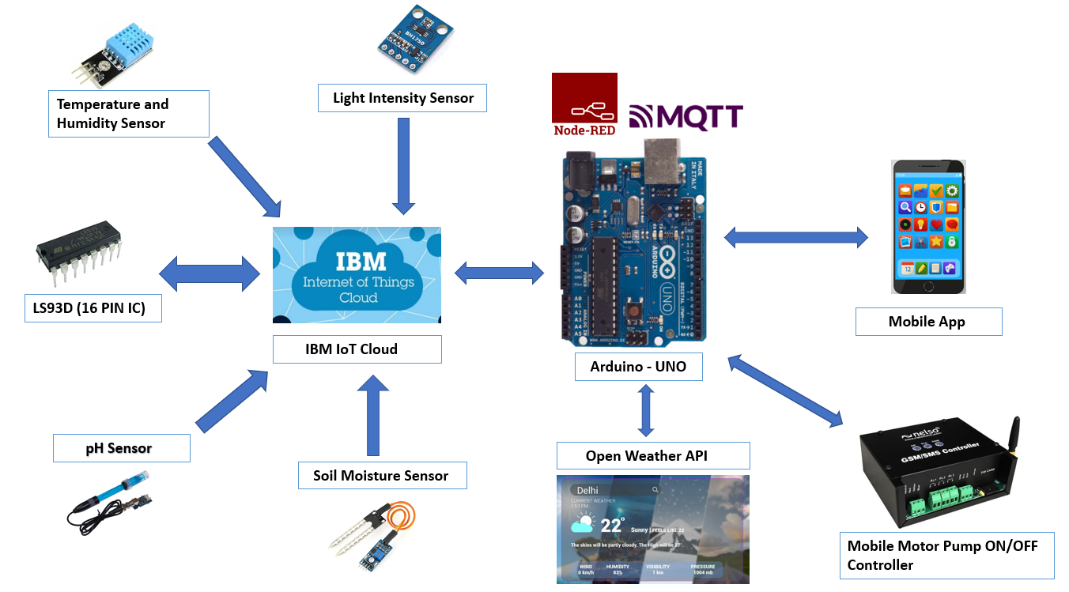

**WORKING**

* The sensors are used to sense various parameters like temperature, pH level, soil moisture and light intensity
* Arduino UNO is a controller unit which process the data obtained from the sensors and send it to the IBM Cloud
* It also processes weather data from the weather API
* Node Red is used as Programming tool
* The MQTT Protocol is used for communication
* All the data collected are sent to the mobile application of the farmer.
* If the sensor value exceeds the threshold or below threshold alerts are sent to the farmer.